ELECENG 3EJ4
Lab Report #4
Instructor: Dr. Chen
Jasmine Dosanjh – dosanj5 – 400531879
November 16, 2025

Part 1: Negative Feedback Amplifier

Q1. (10 Points)
(1) Based on the simulation data in Step 1.2 (Figure 1) the low frequency (100 Hz) voltage gain in dB is:
$$A_{d1}=7.38 dB$$
$$A_{d2}=70.05 dB$$
$$A_{d3}=0 dB$$
(2) The overall voltage gain for the differential-mode signal is
$$A_{d}=7434.5 \frac{V}{V}$$
Figure 1. Step 1.2 Data
(3) The non-inverting input of the op-amp is $V_{2}$ because its phase is 180 degrees which is the same as the output voltage phase (Figure 2).
Figure 2. Step 1.2 Low Frequency
(4) The upper 3-dB frequency $f_{H}$ is the frequency at which the amplitude becomes $\frac{1}{\sqrt{2}}=0.707$ of its low frequency value, or the phase changes $45°$. This gives us:
$${Phase}_{H}={Phase}_{L}-45°=135°$$
$$f_{H}= 6195 Hz$$
Figure 3. Step 1.2 High Frequency

Q2. (5 Points)
Comparing the simulated differential-mode gain of Q1 Stage 1 and Lab 3 Q5 respectively…
$$A_{d1}=7.38 dB$$
$$A_{d}=70.07 dB$$
These two gains are different even though the differential amplifier is the same because Lab 4’s differential amplifier uses negative feedback. Negative feedback expands the amplifier’s bandwidth but causes a lower gain. This is seen by the feedback circuit-gain formula which represents both the amplifier and negative feedback circuit:
$$A_{f}=\frac{A}{1+Aβ}$$
This shows us that the amplifier’s gain A, decreases by a factor of $1+Aβ$ when negative feedback is introduced.

Q3. (5 Points)
Based on the simulated results from Steps 1.2 and 1.3, the input and output resistance of the op-amp is,
$$R_{in}=81757.3 Ω$$
$$R_{out}=460.9 Ω$$

Q4. (10 Points)
(1) Based on the simulated and measured results from Steps 1.6 and 1.13, the plots of the output voltage vs time characteristics at 1 kHz are included below,
Figure 4. Step 1.6
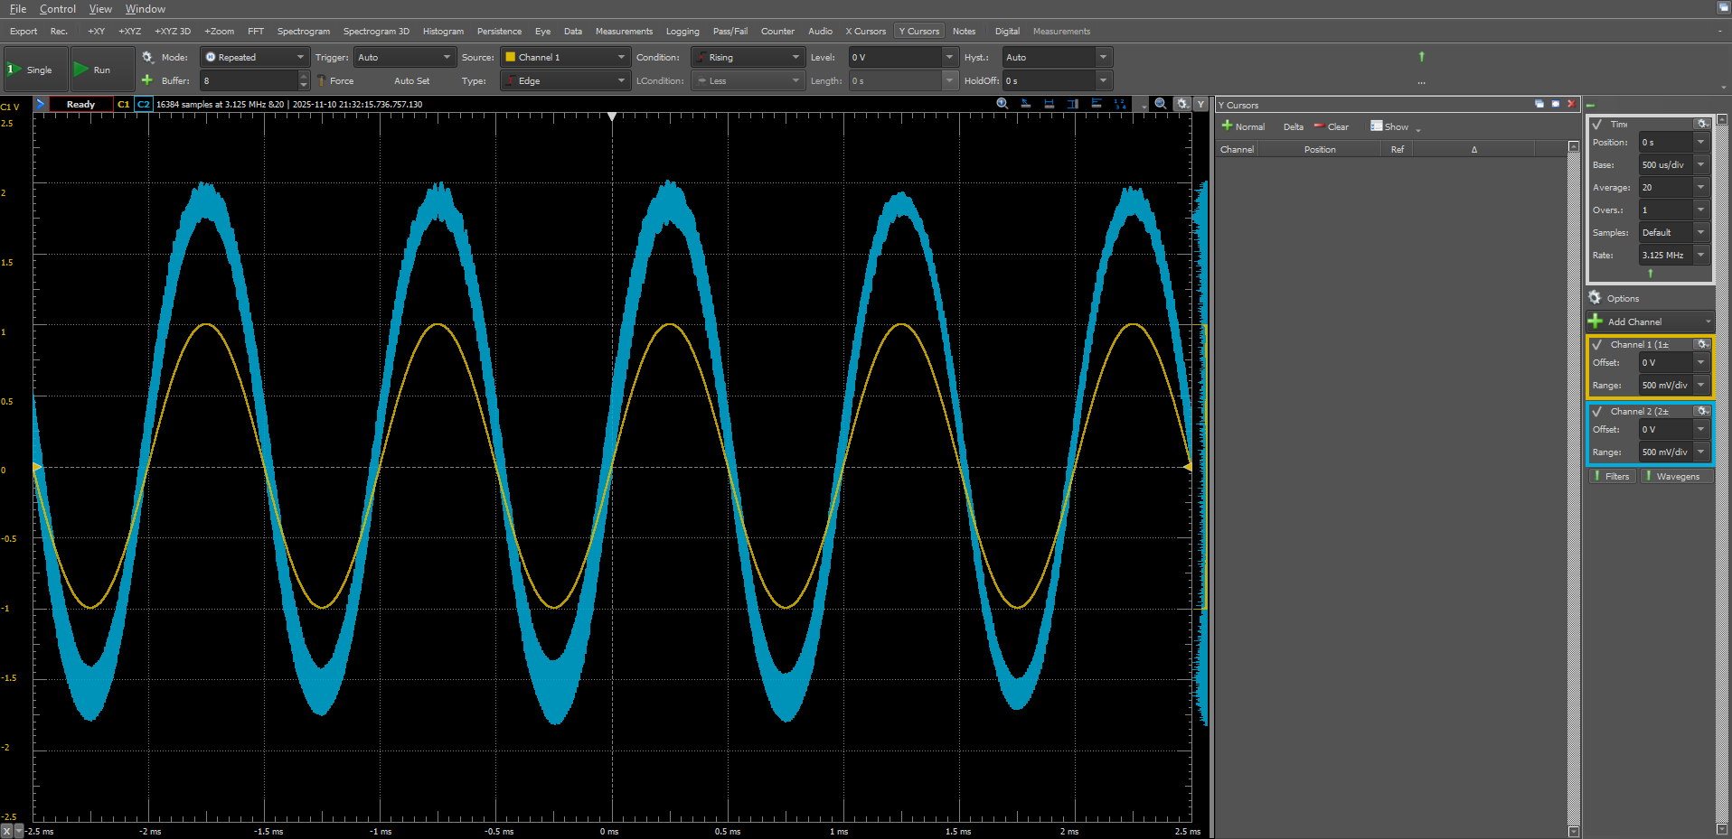
Figure 5. Step 1.13
(2) The simulated and measured peak-to-peak voltage, AC amplitude, and DC voltage of the output are,
Step 1.6 | Step 1.13
$$V_{pp}=0.155-0.151=0.004 V$$  $$V_{p}=\frac{V_{pp}}{2}=\frac{0.004}{2}=0.002 V$$  $$V_{dc}=V_{pp}-V_{p}=0.155-0.002=0.153 V$$ | $$V_{pp}=2-\left(-1.80\right)=3.8 V$$  $$V_{p}=\frac{3.8}{2}=1.9 V$$  $$V_{dc}=2.5-2= 0.5 V$$
These results differ due to the different input AC amplitudes in Step 1.13 (1 V) and Step 1.6 (1 mV).

Q5. (10 Points)
(1) Based on the simulated and measured results from Steps 1.7 and 1.14, the plots of voltage gain magnitude and phase vs. frequency characteristics are included below,

Figure 6. Step 1.7
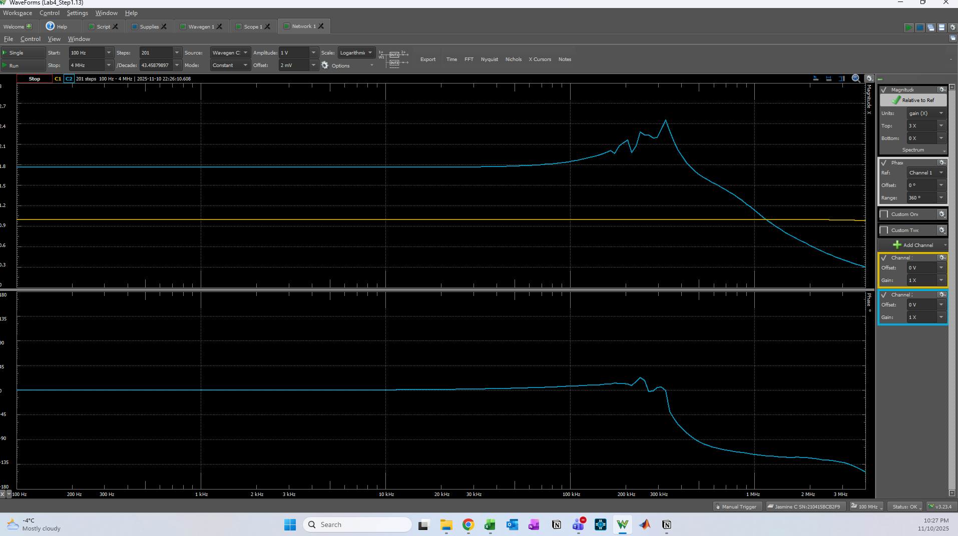

Figure 7. Step 1.14

The low-frequency gain of this amplifier is
$A_{L}=2 V/V$ @ $f_{L}= 1000 Hz$ (simulation)
$A_{L}=1.77 V/V$ @ $f_{L}= 100 Hz$ (physical)
Figure 8. Step 1.7 Gain
Figure 9. Step 1.14 Gain
(2) To operate this amplifier, the highest operating frequency to provide a constant gain as designed can be observed as 100 kHz in Figure 7.

Q6. (5 Points)
The amplifier in Figure 2 has a series-shunt negative feedback configuration. This is because the input has no branch out, nor is it connected to a Common-base PNP BJT, which implies Sum V₁ in Series and the output probe is measuring the output voltage from the Load resistance to the ground, thus it is Sense V_{o} in Shunt. This can be seen in the figure 10 below:
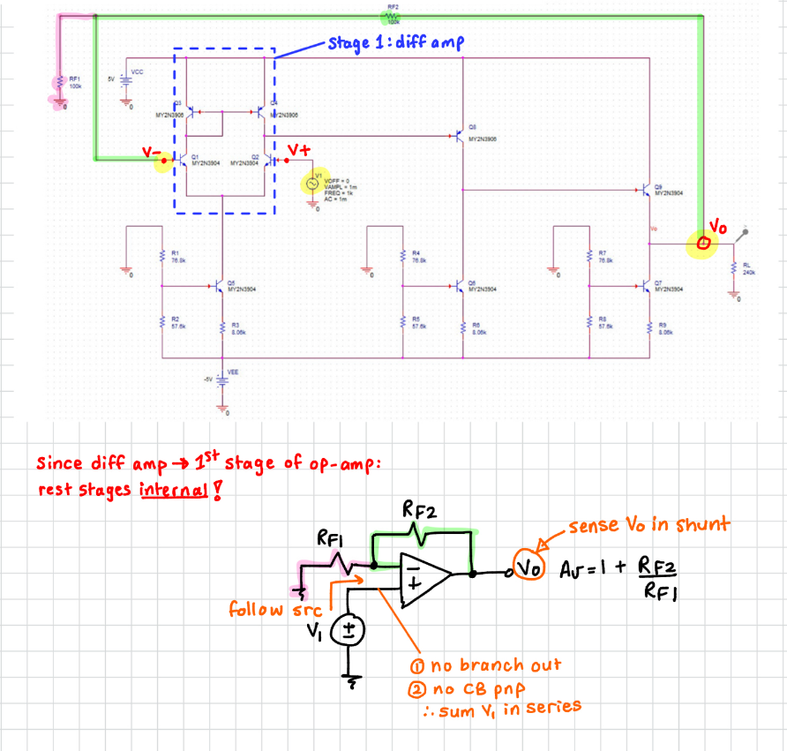
Figure 10. Multistage Op-amp Representation

Q7. (10 Points)
To find the Beta network, we must first separate the amplifier and the Beta network using the technique mentioned in class…
- For the Sum V₁ in Series connection, we must cut the wire connected to the input feedback node, this represents port 1 of the Beta network.
- For the Sense V_{o} in Shunt connection, we must cut the feedback wire connected to the output node, this represents port 2 of the Beta network.

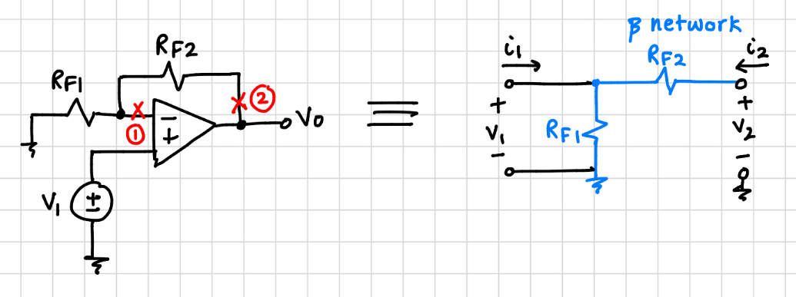
Figure 11. Separating Beta Network and Amplifier
In question 6 we determined that this is a series-shunt configuration, thus series implies there is a current excitation $i_{1}$ at port 1, and shunt implies a voltage excitation $v_{2}$ at port 2. This means the Beta network corresponds to the h-parameters:
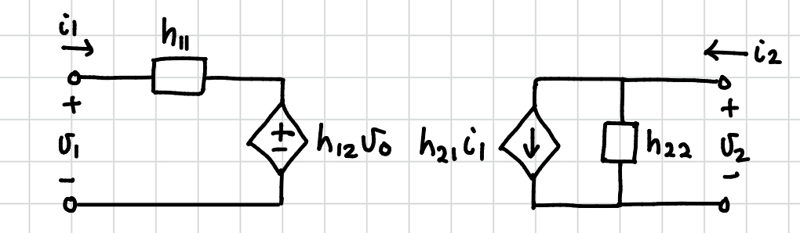
Figure 12. Two-Port Network h-parameter model
$$v_{1}=h_{11}i_{1}+h_{12}v_{2}$$
$$i_{2}=h_{21}i_{1}+h_{22}v_{2}$$

Using this information, we can find $β,R_{11},$ and $R_{22}$ by replacing the beta network with the two port network model:
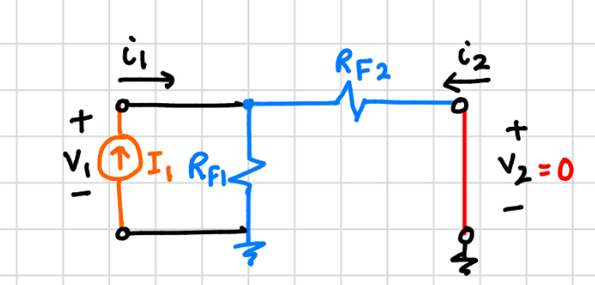
Figure 13. Circuit to find h11
$$h_{11}={\left.\frac{v_{1}}{i_{1}}\right|}_{v_{2}=0}=R_{11}$$
$$v_{1}=i_{1}(R_{F1}\left\|R_{F2}\right.)$$
$$\frac{v_{1}}{i_{1}}=R_{F1}\left\|R_{F2}\right.$$
$$∴R_{11}=R_{F1}\left\|R_{F2}\right.=100k\left\|100k\right.=50k$$

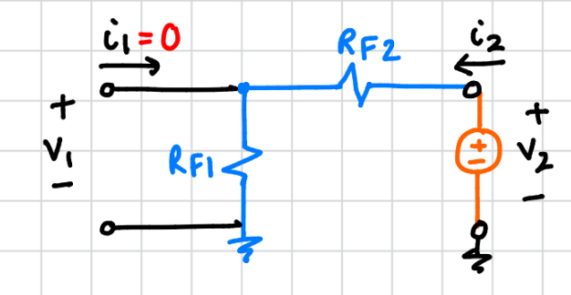
Figure 14. Circuit to find h12 and h22
$$h_{12}={\left.\frac{v_{1}}{v_{2}}\right|}_{i_{1}=0}=β$$  $$v_{1}=\frac{R_{F1}}{R_{F1}+R_{F2} }v_{2}$$  $$\frac{v_{1}}{v_{2}}=\frac{R_{F1}}{R_{F1}+R_{F2} }$$  $$∴β=\frac{R_{F1}}{R_{F1}+R_{F2} }=\frac{100k}{100k+100k }=0.5$$ | $$h_{22}={\left.\frac{i_{1}}{v_{2}}\right|}_{i_{1}=0}=\frac{1}{R_{22}}$$  $$i_{2}=\frac{v_{2}}{R_{F1}+R_{F2} }$$  $$\frac{v_{2}}{i_{2}}=R_{F1}+R_{F2}$$  $$∴R_{22}=R_{F1}+R_{F2}=100k+100k =200k$$

Q8. (15 Points)
We can determine the amplifier’s voltage gain, input resistance and output resistance by using the amplifier’s three parameter model, where $h_{21}$ is negligible, $R_{11}$ and $R_{22}$ are disconnected from the Beta network and attached to the new amplifier circuit A’;
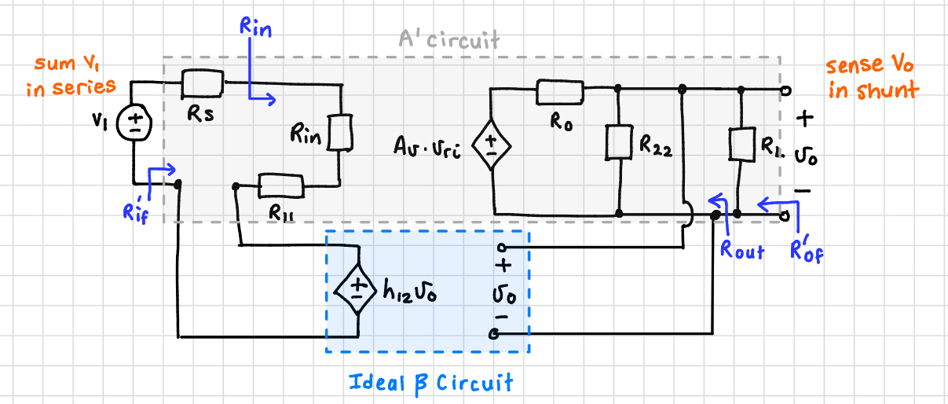
Figure 14. Three Parameter Model
The Simulated values are bolded:
- $A_{vf}^{'}=\frac{A_{v}^{'}}{1+A_{v}^{'}β}≈\frac{1}{β}=\frac{1}{0.5}=2\frac{V}{V}$
- $A_{v}^{'}=\frac{v_{o}}{v_{1}}=\frac{v_{o}}{v_{ri}}×\frac{v_{ri}}{v_{1}}$ $v_{ri}=\left(\frac{R_{in}}{R_{in}+R_{11}+R_{s}}\right)v_{1}$ $v_{o}=\left(\frac{R_{22}\left\|R_{L}\right.}{R_{o}+R_{22}\left\|R_{L}\right.}\right)A_{v}v_{ri}$
$$A_{v}^{'}=A_{v}\left(\frac{R_{22}\left\|R_{L}\right.}{R_{o}+R_{22}\left\|R_{L}\right.}\right)×\left(\frac{R_{in}}{R_{in}+R_{11}+R_{s}}\right)$$
$$=7434.5\left(\frac{200k\left\|240k\right.}{0.4609k+200k\left\|240k\right.}\right)×\left(\frac{81.7573k}{81.7573k+50k+0}\right)$$
$$=4595.6$$
- $R_{in}^{'}=R_{in}+R_{11}+R_{s}=\left(81.7573kΩ+50k+0\right)=131.7573kΩ$
- $R_{inf}^{'}=\left(1+A_{v}^{'}β\right)R_{in}^{'}=\left(1+\left(4595.6 \right)\left(0.5\right)\right)\left(131.7573k\right)=302.9MΩ$
- $R_{o}^{'}=R_{o}\left\|R_{22}\right.\left\|R_{L}=460.9\left\|200k\right.\left\|240k=458.9Ω\right.\right.$
- $R_{of}^{'}=\frac{R_{o}'}{1+A_{v}^{'}β}=\frac{458.9}{\left(1+\left(4595.6 \right)\left(0.5\right)\right)}=0.2 Ω$

Part 2: Positive Feedback Circuit – Oscillator
Q9. (15 Points)
For the oscillator circuit, its Loop Gain, frequency for the zero-loop phase, and $R_{2}/R_{1}$ for oscillation are derived below,
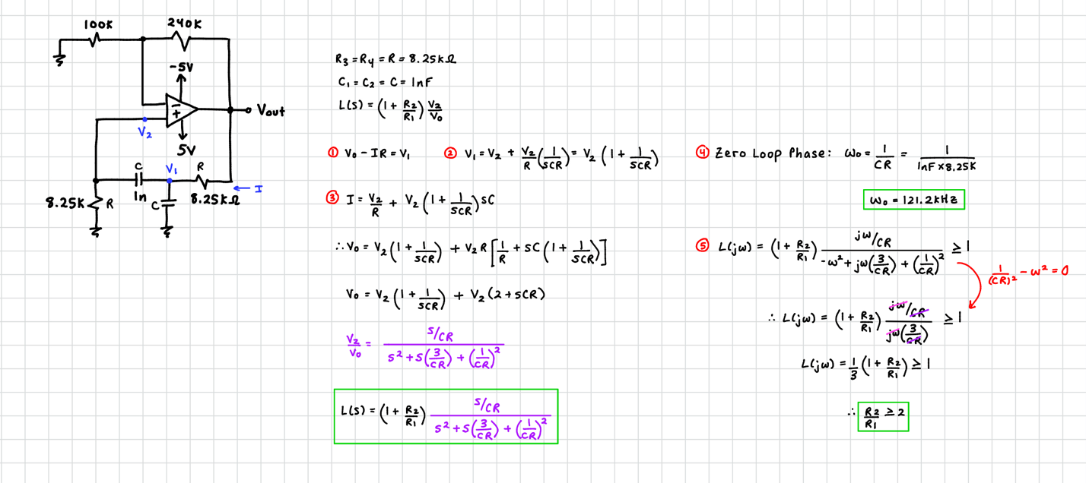
Q10. (5 Points)
Based on the simulated results in Step 2.4, the settling times for $R_{2}=220 kΩ,240 kΩ,$ and $280 kΩ$ are,
Figure 13. Step 2.4 Data
$$R_{2}=220 kΩ→1.77 ms$$
$$R_{2}=240 kΩ→0.921 ms$$
$$R_{2}=280 kΩ→0.480 ms$$
The observed trend is that resistance and settling time are inversely proportional. As the resistance increases from $220$ to $280 kΩ$, the settling time decreases from 1.77 to 0.48 ms. This relationship can be explained by the equation derived in question 10:
$$L\left(s\right)=\left(1+\frac{R_{2}}{R_{1}}\right)\frac{s/CR}{s^{2}+s\left(\frac{3}{CR}\right)+{\left(\frac{1}{CR}\right)}^{2}}$$
It is clear that L(s) is proportional to R2. If R2 increases, so will L(s). A higher loop-gain shifts the dominant pole of the circuit to a higher frequency, which reduces the settling time.

Q11. (10 Points)
(1) Based on the setup in Steps 2.3, 2.5, 2.8, and 2.9, the plots of the simulated and measured output voltages are included below,
Figure 14. Step 2.3 | Figure 15. Step 2.5

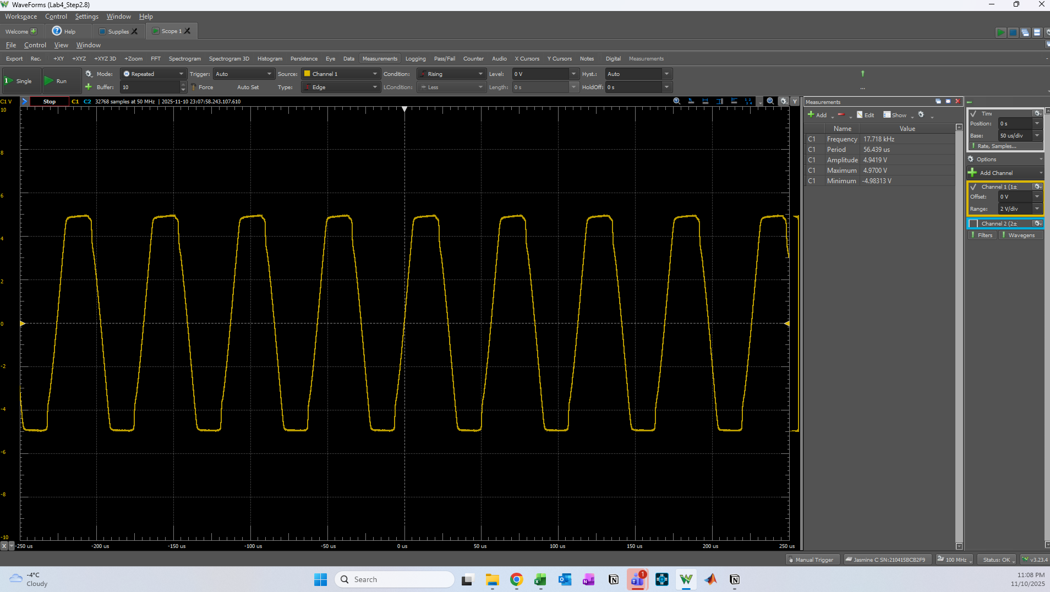
Figure 13. Step 2.8
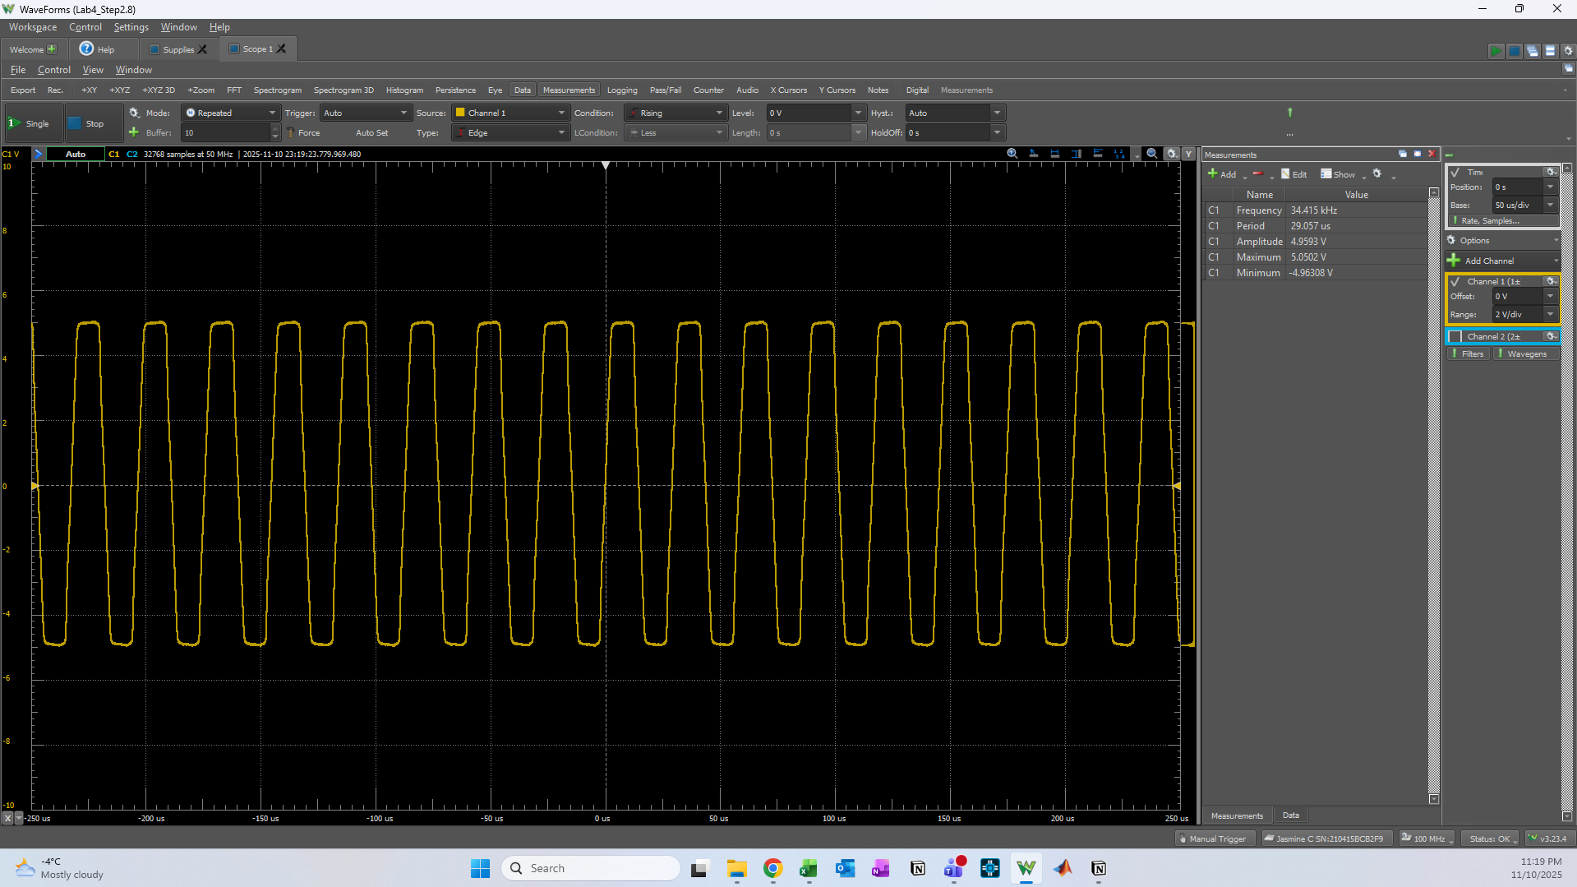
Figure 14. Step 2.9
(2) Step 2.3: $f=\frac{1}{T}=18 kHz$
Step 2.5: $f=\frac{1}{T}=34 kHz$
Step 2.8: $17.718 kHz$
Step 2.9: $34.415 kHz$
The measured values above are similar to the simulated values. From Question 9, we know that $ω=1/CR$, showing that frequency and resistance are inversely proportional. Decreasing $R_{3}=R_{4}=8.25 kΩ$ to $4.02 kΩ$, we approximately half the resistance, and as seen above, we nearly double the frequency from 18 to 34 kHz.

